Mini Hardware Problem: Audio Pass-through

First, need to know what computer outputs through 3.5mm headphone jack. Using an online tone generator website and connecting a 3.5mm jack to my laptop with the two audio ends stripped down to copper:

<https://onlinetonegenerator.com/frequency-sweep-generator.html>

Generating a sweep from 1Hz to 25,000 over 10 seconds at 100% volume

|  |  |
| --- | --- |
| https://media.discordapp.net/attachments/765008126394105878/767464793279561728/unknown.png?width=343&height=593 |  |

My laptop output is ~1.8Vpp with ~+-0.9V at most frequencies (dips down in lower frequencies). This is with “Windows Sonic for Headphones” turned off in my Windows sound settings.

I googled “bipolar audio signal to unipolar adc” and found a Stack Exchange post asking how to convert +-3.5V to 0🡪5V:

https://electronics.stackexchange.com/questions/413058/bipolar-to-unipolar-voltage-converter

A guy answered the question with this solution:

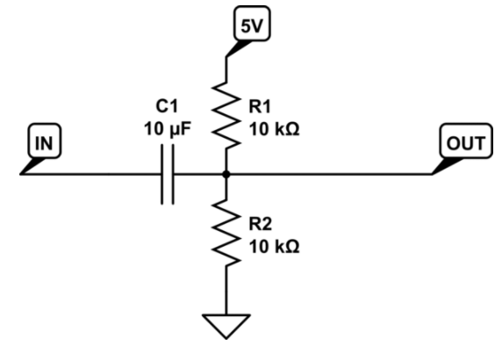

Using the Kinetis K22F 512KB Flash Technical Data Sheet I found the ADC electrical specifications

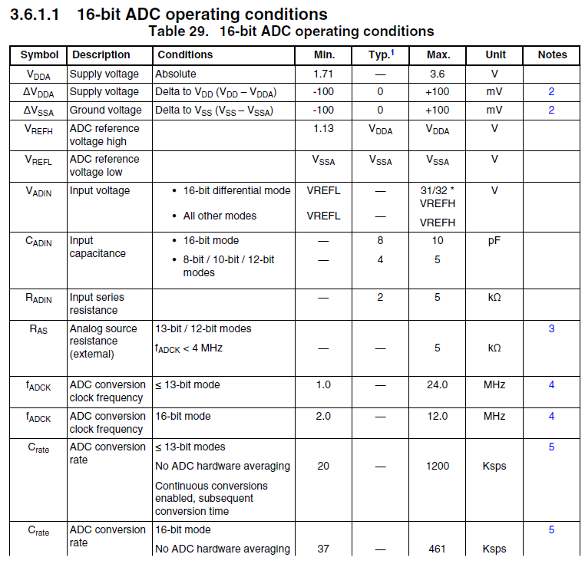



Used “Tina-TI” software to simulate circuit with the input voltage being 20Hz 1Vpp Sine wave, 20,000Hz 1Vpp Sine wave, and example .wav file of jazz music included in Tina-TI software:

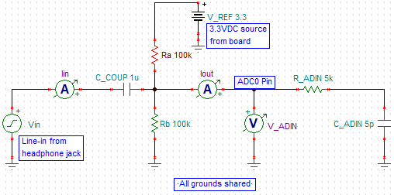

20Hz Sine wave with 1.8Vpp (max = 0.9V)

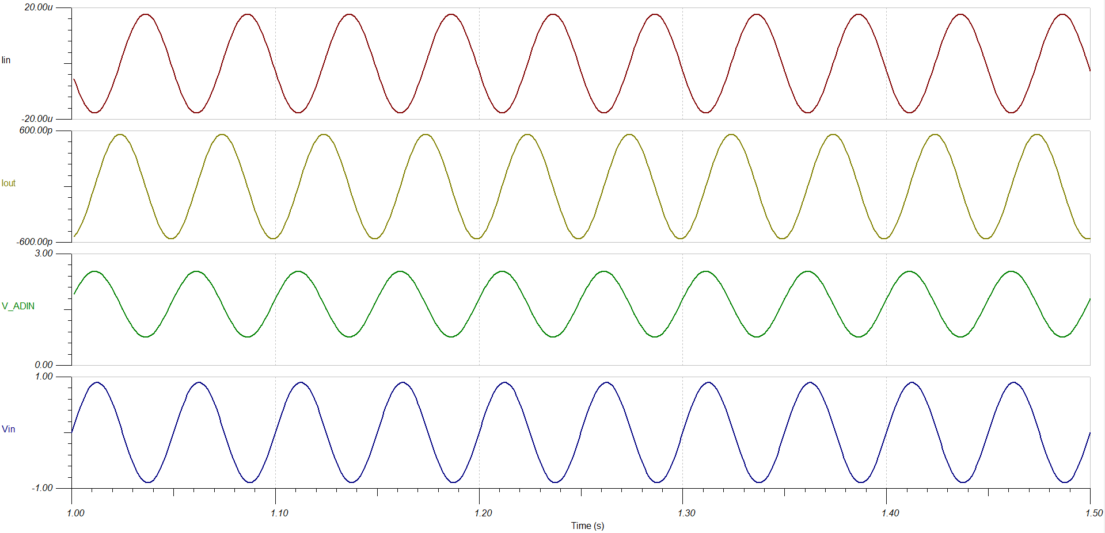

20,000Hz Sine wave with 1.8Vpp (max = 0.9V)

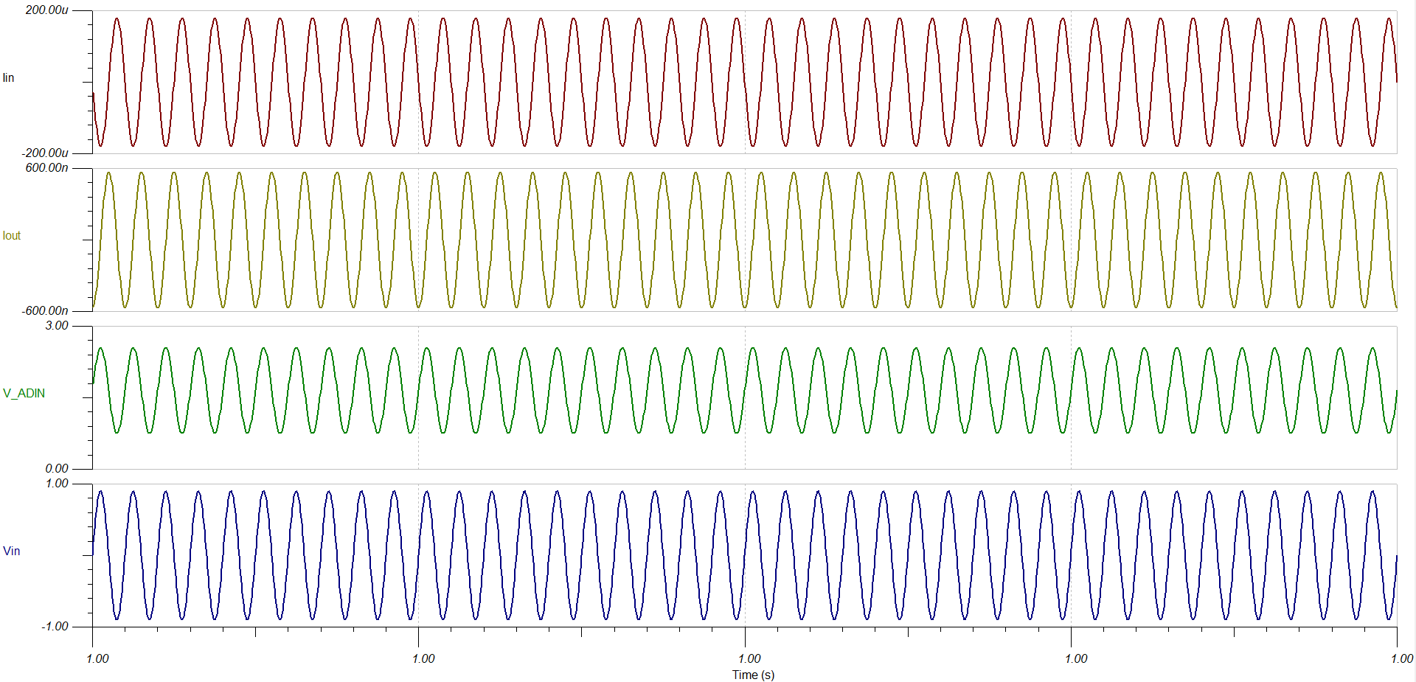

Example .wav file included with Tina-TI software of someone rapping with 1.8Vpp (max of 0.9V)

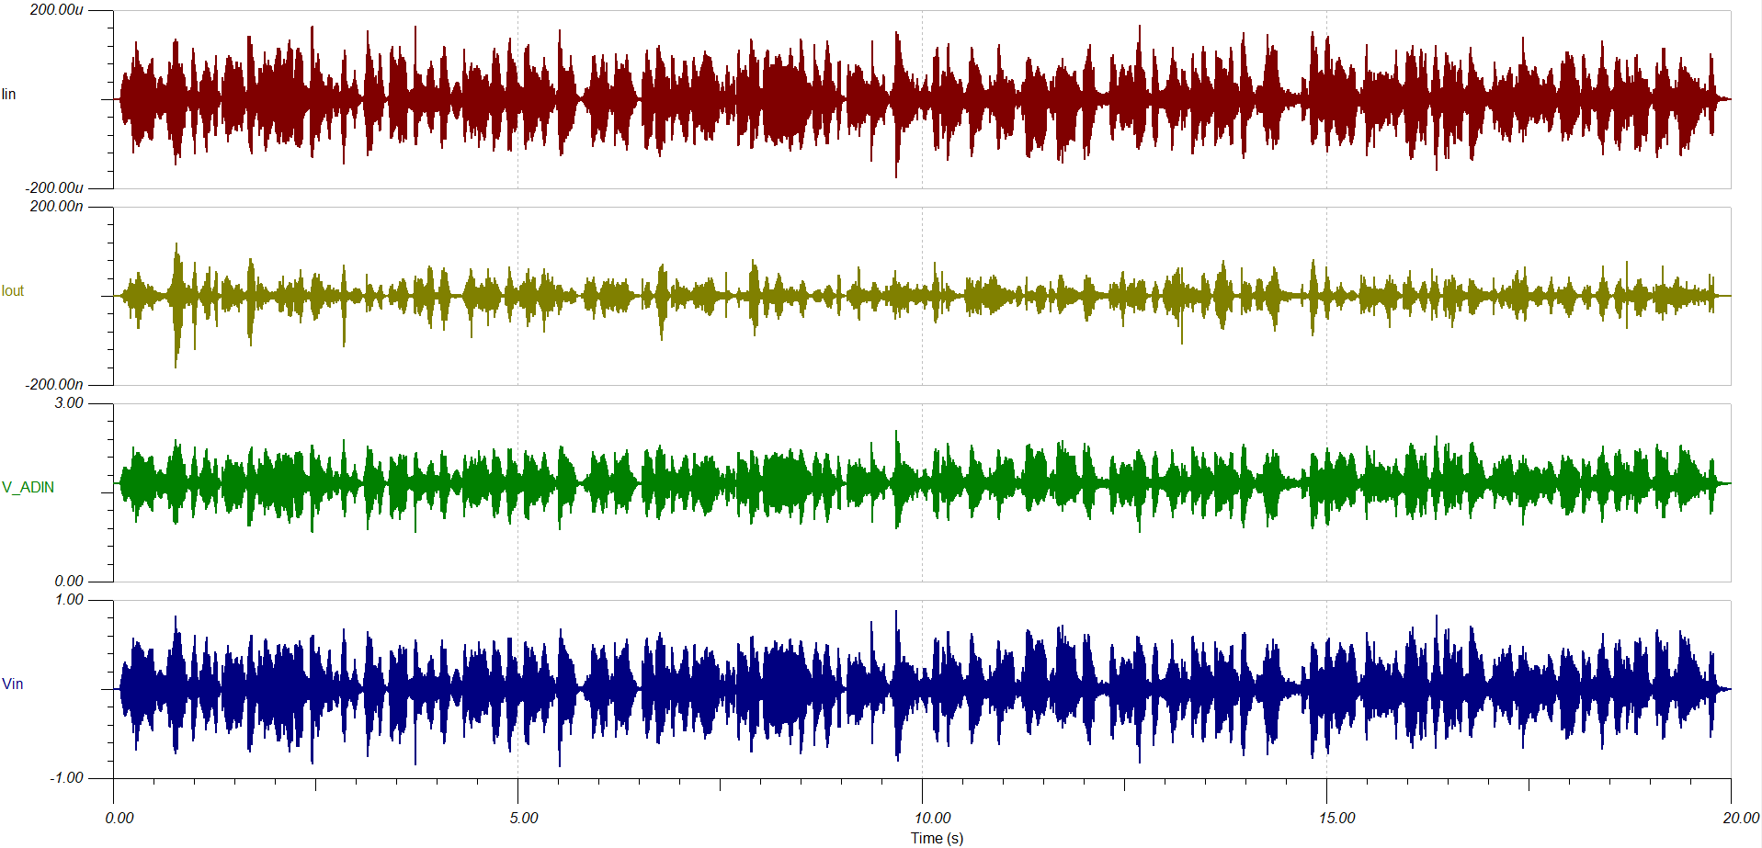

From these simulations we can see that at lower frequencies, the output amplitude is slightly smaller in amplitude, but we still achieve the same offset (1.65VDC). We can see this dip in output amplitude by doing an AC sweep from 20Hz🡪20kHz

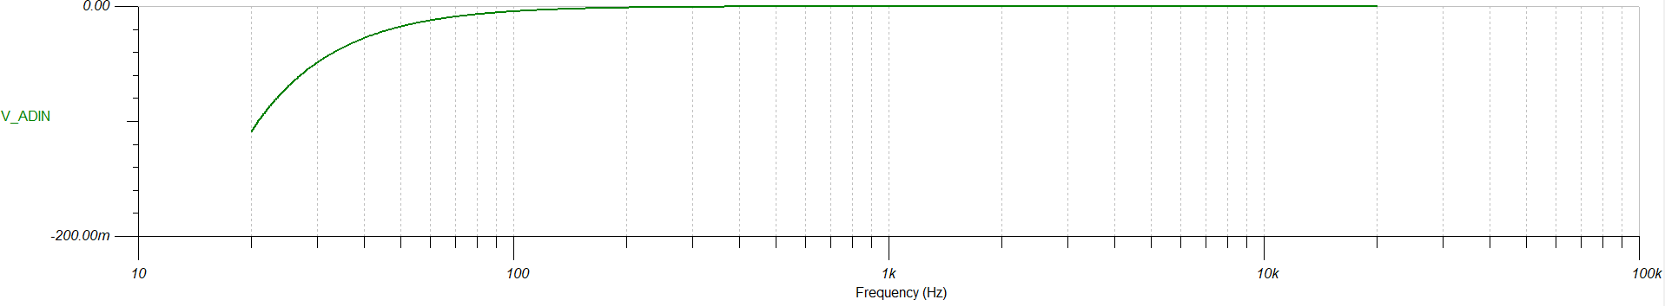

Build in lab, and use waveform generator in place of laptop for input:

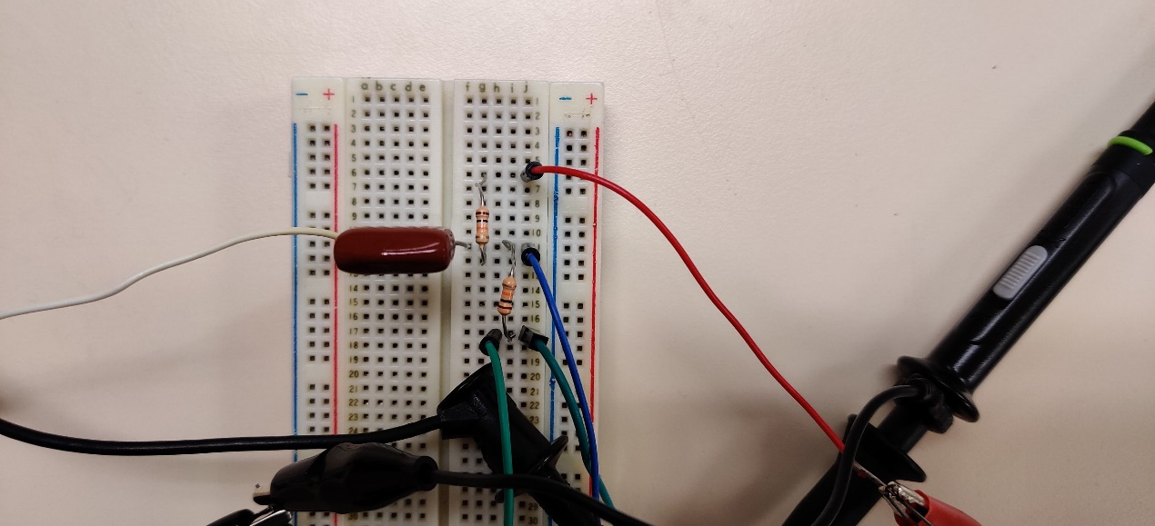

For all scope shots below 1 (Yellow) is audio input, 2 (Green) is output to ADC0

|  |  |
| --- | --- |
|  |  |
|  |  |

This looks like it is working correctly. Unfortunately, the scale factor at lower frequencies (<110Hz) is less than one, but the offset stays at 1.65V which is more important. We could fix this if we increased the capacitor from 1uF to something like 10uF, but we do not have any ceramic capacitors that are that high in lab.